Assemblage

The blending together of component wine lots to form a final composite intended for bottling, for aging, for sparkling wine production or for some other use by the wine maker. Also the name given to formal membership conclaves in the wine fraternity "Knights of the Vine." (from Wine Words: WineWineWine.com)

Symbolic Knight Performing Induction Rights Representing all New Knights and Gentle Ladies

Mr. Terry Waldeesser Senior Knight-in-Training

Aims and Purposes

The Brotherhood is an association of individuals who share an appreciation for and an interest in the vines and wines of America; proclaim their virtues and uses in a modern society by demonstrating the good life with wine through the courtesies of the table; educate themselves and the public at large that wine is a healthy and hygienic beverage and beneficial to modern life; and bring honor and distinction to those individuals who support the cause of the vines and wines of America.
the brotherhood of the
knights of the vine

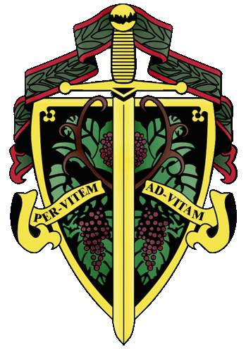

Master Exchequer Joe Alt
The Nation's Capital Chapter

Preamble

Wine is a gift from God that has been used as a food and a symbolic beverage for centuries: we have the privilege to enjoy and appreciate wine. Wine is a gift of nature. Growth of its consumption is a gift of man to man. Therefore, we bind together in the "Brotherhood" to enjoy and appreciate its use by telling of this gift in the world and by teaching Restraint and Reason.
AT THE EVENTIDE OF THE 15th DAY OF MARCH IN THE YEAR OF
OUR LORD 2014

The Cadre of the Nation's Capital Chapter of the Brotherhood of the Knights of the Vine Welcomes You to The City Tavern Club in Georgetown for the Elevation of Members, the Knighting of New Members and the Formal Dinner in Celebration of Their Acceptance into the Peerage

Officiating Officers

Master Commander Kenneth A. Haapala
Master Vice Commander Charles (Russ) Davis
Master Exchequer John (Joe) Alt
Master of Ceremonies David A. Barber
Master Aviatrix Margy Natalie
Master Heralder Walter J. Rachele
Master Boulevardier Anthony Ramdass

Events

Gathering of the Peerage • 6:00 pm

Assemblage • 6:30 pm
Duties of Symbolic Knight
Celebration of Membership

Champagne Reception • 7:15 pm
Passed Hors d’Oeuvres

Enthronement Dinner • 8:00 pm
Dinning Room

Per Vitem! Ad Vitam!
Through the Vine! Towards Life!
Champagne Reception

Oysters on the half shell, mignonette and cocktails sauces
Caviar canapé
Foie Gras canapé
Selected Champagnes and Sparkling Wines
A.R. Lenoble, Grand Cru, Millésime, Blanc de Blancs, 1990

Enthronement Dinner Honoring Membership

Peloridis
Tequila and lime grilled Gulf Shrimp
Heirloom tomatoes, lardons, and baby spinach

Bai Gorri Blanco, Cosecha

Anetina
Pan roasted Maple Leaf Duck Breast
Warm duck confit salad, hearts of palm, candied garlic,
Grand Marnier and Sherry vinaigrette
Medici Vineyards Pinot Noir, Estate Reserve, Block I, II, 2007,
Willamette Valley
Bootjack Ranch Merlot, Bootjack Ranch, Niner Wine Estates, 2010,
Paso Robles

Interquiesco

Pecus
Yellowstone Park Wild Buffalo Tenderloin
Chanterelles, roasted shallots, fingerling potatoes, in a Madera wine sauce
Fiddletown Cellars Zinfandel, Old Vine, 2011, Amador County
Revelry Cabernet Franc, Merlot, Cabernet Sauvignon blend, 2010, Columbia Valley,

Moretum
Baby Manchego, Cashel Blue Cheese, Cahill’s Whiskey Cheddar
California nuts, warm fruit compote, Carr’s crackers and sliced baguette
Halćon Syrah, Alturas, 2011, Yorkville Highlands, California
Huarpe Malbec and Cabernet Sauvignon blend, 2009, Mendoza, Argentina

Bellaria
Valrhona Chocolate Crème Brulee
Pocas Special Reserve Ruby, Porto, Portugal
Pocas Special Reserve Tawny, Porto, Portugal

Hosted by Master Knight Edward Brennan

Created and Executed by Chef Robert Polk

