Supreme Knight Gordon Wallace Murchie
(October 2, 1932 to March 16, 2019), RIP

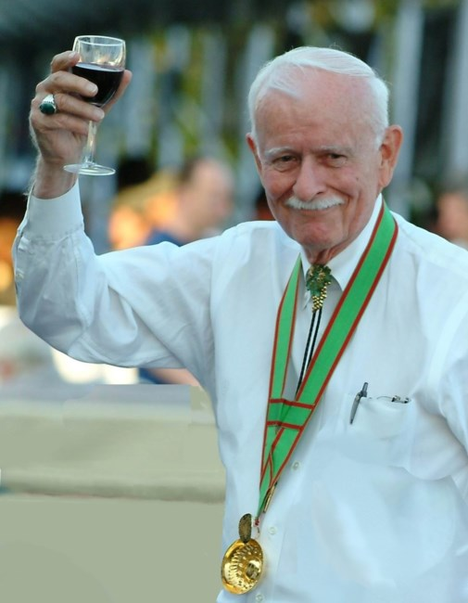

On March 16, we lost a champion for the wines and vines of America, particularly for those of Virginia. Gordon Murchie’s diplomacy and infectious enthusiasm for American wines greatly benefited the industry and consumers alike. With great charm and passion for wines, he helped overcome many traditional obstacles to the enjoyment of wines. American wineries have faced political opposition, inherent distrust by regulators, regulatory excesses urged by entrenched distributers, personal feuds by competitors, and all too enthusiastic embrace by some supporters.

Gordon worked diligently to overcome these obstacles with reason, restraint, and an almost never-ending encyclopedic knowledge of the importance of wine in many cultures for thousands of years.

For 35 years, Gordon was a Foreign Service Officer in the US Information Agency and the US Agency for International Development, serving in The Philippines, Indonesia, Thailand and Costa Rica. Upon retirement, he became a leader in the Virginia wine industry, greatly assisting its emergence as a major producer of high-quality wines.

In so doing, he fostered the appreciation of American wines and the importance of the industry to our nation. He helped create the bipartisan Congressional Wine Caucus to overcome political and regional differences and to foster growth of the entire industry. For years, Gordon served as president of Virginia’s Vinifera Wine Growers Association, which, in keeping with his national vision, became the Atlantic Seaboard Wine Association in 2008.

The Atlantic Seaboard association promotes American wine produced in the seventeen eastern states – those touching the Atlantic Ocean plus West Virginia, Pennsylvania and Vermont. It holds annual competitions and often the awards are presented in Congressional buildings, with Congressmen and staff members from various states participating. The event helps many in Washington to realize the national character of the American wine industry, so typical of Gordon.

With Anita, his wife of 63 years, Gordon edited “The Wine Exchange,” the newsletter of The Vinifera Wine Growers Association, for several years. Keeping with Gordon’s desire to promote wine education, in addition to topics on wine and wineries, the newsletter had thought provoking commentary on topics such as: the health benefits of wine; cultural history of wine and wine making; wine and nutrition; building a better image for the industry; and properly meeting regulatory requirements for special events, such as wine festivals.

Many articles were prepared by Congressmen, key regulators, and experts in fields such as health. Such newsletters helped provide a commonality of interests and an atmosphere of cooperation. The relaxation of regulations on direct shipping in many states is an example of Gordon’s efforts, combined with the efforts of many others.

In addition, Gordon led wine delegations to a number of countries such as Greece, South Africa, and China to promote better understanding of wine cultures and wine appreciation around the world.

In 1997, Gordon W. Murchie became the only Supreme Knight the Nation’s Capital Chapter of the Brotherhood of the Knights of the Vine ever had. He earned the distinction nobly and wore it proudly.

We will miss him dearly.

Per Vitem! Ad Vitam!
Kenneth A. Haapala, Grand Vice Commander
Master Commander, Nation’s Capital Chapter
The Brotherhood of the Knights of the Vine

On April 13, Domaine Funeral Home, 5308 Backlick Road, Springfield, VA 22161 will have a reception and ceremony for Gordon from 4:00pm to 7:00 pm. (703-941-9422)

